**JAVA**

**Introducción**

* Desarrollado por **Sun Microsystems** y adquirido por **ORACLE en 2010**.
  + Su sintaxis deriva en gran medida de [C](https://es.wikipedia.org/wiki/C_(lenguaje_de_programaci%C3%B3n)) y [C++](https://es.wikipedia.org/wiki/C%2B%2B). Es un [lenguaje de programación](https://es.wikipedia.org/wiki/Lenguaje_de_programaci%C3%B3n) de [propósito general](https://es.wikipedia.org/wiki/Lenguaje_de_programaci%C3%B3n_de_prop%C3%B3sito_general), [concurrente](https://es.wikipedia.org/wiki/Computaci%C3%B3n_concurrente), [orientado a objetos](https://es.wikipedia.org/wiki/Programaci%C3%B3n_orientada_a_objetos), que fue diseñado específicamente para tener tan pocas dependencias de implementación como fuera posible. Su intención es permitir que los [desarrolladores](https://es.wikipedia.org/wiki/Desarrollador_de_software) de aplicaciones escriban el programa una vez y lo ejecuten en cualquier dispositivo
* **Tres posibles plataformas:**
  + **Java SE:** la conocida como **Standard Edition** es la edición más difundida de la plataforma Java. Incorpora los elementos necesarios para crear **aplicaciones de escritorio** con o sin interfaz gráfica de usuario, acceso al sistema de archivos, comunicación a través de redes, concurrencia y otros servicios básicos.
    - **JavaFX:** originalmente JavaFX era una alternativa a Java SE para el desarrollo de proyectos de tipo RIA (**Rich Internet Applications**), con un núcleo más ligero y fácil de distribuir, capacidad de aceleración 3D aprovechando la GPU, servicios avanzados para producción de gráficos y animaciones, y un mecanismo simplificado para el diseño de interfaces de usuario. JavaFX **forma parte de Java SE desde la versión 7** de dicha edición de la plataforma.
  + **Java EE:** es la **Enterprise Edition** de la plataforma Java, dirigida al desarrollo de soluciones software que se ejecutarán en un **servidor de aplicaciones**. A las capacidades de Java SE, la edición EE agrega servicios para gestionar la persistencia de objetos en bases de datos, hacer posible la invocación remota de métodos, crear aplicaciones con interfaz de usuario web, etc.
  + **Java ME:** esta edición de la plataforma, **Micro Edition**, está enfocada a la creación de programas que se ejecutarán en sistemas con recursos limitados, tales como teléfonos móviles, electrodomésticos y dispositivos de domótica o equipos para entornos empotrados como la Rasperry Pi y similares.

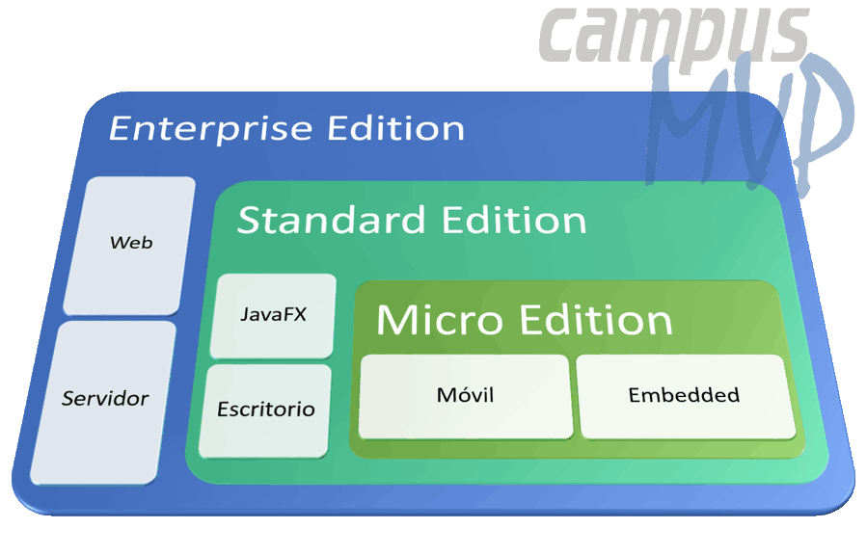

## Types of Java Applications

There are mainly 4 types of applications that can be created using Java programming:

**1) Standalone Application**

Standalone applications are also known as desktop applications or window-based applications. These are traditional software that we need to install on every machine. Examples of standalone application are Media player, antivirus, etc. AWT and Swing are used in Java for creating standalone applications.

**2) Web Application**

An application that runs on the server side and creates a dynamic page is called a web application. Currently, [Servlet](https://www.javatpoint.com/servlet-tutorial), [JSP](https://www.javatpoint.com/jsp-tutorial), [Struts](https://www.javatpoint.com/struts-2-tutorial), [Spring](https://www.javatpoint.com/spring-tutorial), [Hibernate](https://www.javatpoint.com/hibernate-tutorial), [JSF](https://www.javatpoint.com/jsf-tutorial), etc. technologies are used for creating web applications in Java.

**3) Enterprise Application**

An application that is distributed in nature, such as banking applications, etc. is called an enterprise application. It has advantages like high-level security, load balancing, and clustering. In Java, [EJB](https://www.javatpoint.com/ejb-tutorial) is used for creating enterprise applications.

**4) Mobile Application**

An application which is created for mobile devices is called a mobile application. Currently, Android and Java ME are used for creating mobile applications.

* **Partes**

Dos partes muy diferenciadas dentro de la plataforma Java

:

**JRE (*Java Runtime Environment*)**: su objeto es aportar el entorno necesario para ejecutar una aplicación Java. Forman parte del JRE la **máquina virtual Java o JVM** (*Java Virtual Machine*), encargada de ejecutar el [*bytecode*](https://es.wikipedia.org/wiki/Bytecode) Java, así como las bibliotecas que ofrecen los servicios definidos en la plataforma.

**JDK (*Java Development Kit*)**: es el paquete de herramientas para llevar a cabo el desarrollo de dicha aplicación. Este JDK es un superconjunto del JRE, al que agrega herramientas como el **compilador Java**. Este toma el código fuente Java y genera como resultado *bytecode*, un formato de código objeto independiente del sistema operativo y el hardware.

* **Máquina Virtual de Java JVM ( Java Virtual Machine)**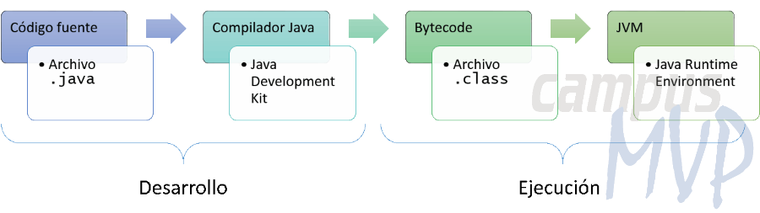
  + Cuando compilas una aplicación escrita en lenguaje Java, en realidad éste no se compila a lenguaje máquina directamente entendible por el sistema operativo, sino a un lenguaje intermedio denominado **Byte Code**. Lo mismo ocurre con las aplicaciones .NET que se compilan también [a un lenguaje intermedio llamado MSIL (MicroSoft Intermediate Language)](https://www.campusmvp.es/recursos/post/que-es-la-plataforma-net-y-cuales-son-sus-principales-partes.aspx).
  + Entre el Byte Code (o el MSIL en el caso de .NET) y el sistema operativo se coloca un componente especial llamado **Máquina virtual** que es el que realmente va a ejecutar el código. En el caso de Java, La Java Virtual Machine o JVM toma el código Byte Code resultante de compilar tu aplicación Java y lo compila a su vez a código nativo de la plataforma en la que se está ejecutando. La ventaja principal de este esquema es que es muy fácil [crear un programa en Java](https://www.campusmvp.es/catalogo/Product-Desarrollo-de-aplicaciones-con-la-plataforma-Java_231.aspx) y que luego éste se pueda ejecutar en cualquier sistema operativo para el cual exista una implementación de la JVM.
  + **Write Once, Run Anywhere**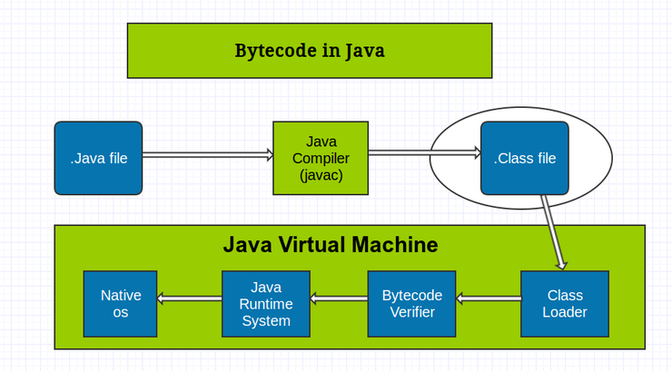
* **El Compilador Just In-Time o JIT o Compilador en tiempo real :** 
  + La ejecución del Byte Code es lenta comparada con la del código nativo en cada plataforma. La JVM primero tiene que cargar el código y traducirlo a instrucciones nativas para poder ejecutarlo, haciendo otras muchas cosas por el medio, como comprobar los tipos, recoger basura, etc… Una manera de optimizarlo y conseguir un alto rendimiento es hacer una compilación inmediata, lo antes posible, al código nativo de cada plataforma, cacheando además los resultados para reutilizarlos. Esto es básicamente lo que hace este componente, cuyo nombre viene de esta función: Just In-Time Compiler o compilador en tiempo real. OJO, esto no quiere decir que compile todo el código a código nativo (para eso tendríamos un compilador para cada plataforma, como ocurre con C++, por ejemplo). Lo que hace la JVM es decidir en cada momento qué partes del código se deben compilar con el JIT y cuáles almacenar, cuándo ejecutarlas, etc...Dado que esa compilación también lleva tiempo, el compilador JIT suele compilar a código nativo el código que se use con mayor frecuencia, pudiendo notar una pequeña demora en la ejecución la primera vez que se compila.

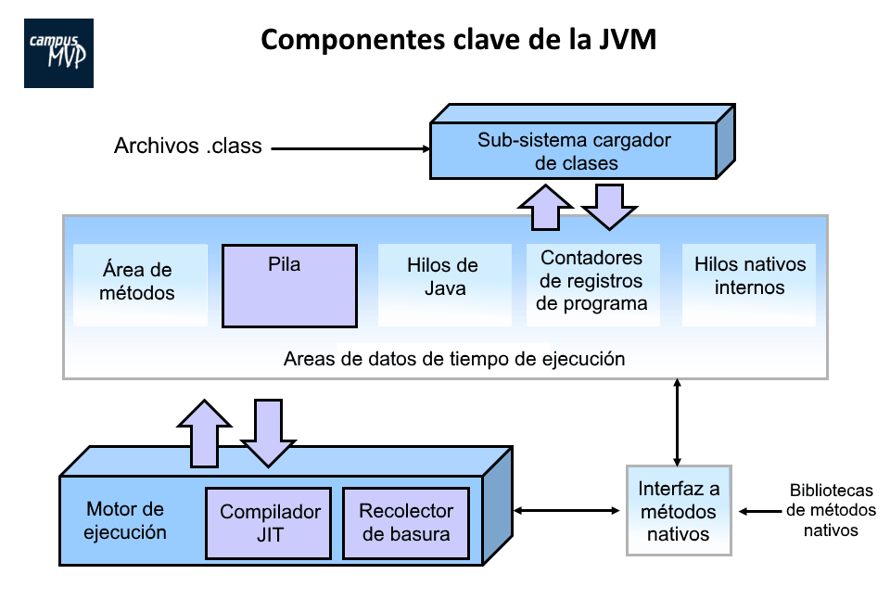

**INSTALACIÓN**

1. Java es gratuita , simplemente dirígete a ORACLE para bajar el JAVA  **JRE** (J.Runtime Enviroment)
   1. [**https://www.java.com/es/download/**](https://www.java.com/es/download/)
   2. [**https://www.java.com/es/download/help/**](https://www.java.com/es/download/help/)
2. Para comprobar que java está instalado teclear desde la línea de comandos:

**java -version**

1. A veces es necesario añadir a la variable PATH la ruta de instalación, que termina en \bin:
   1. PATH = C:\Program Files\Java\jdk-11.0.1**\bin**

**EMPEZANDO A PROGRAMAR**

1. Para poder programar con JAVA necesitas el JAVA **JDK ( J.Development Kit)**
   1. [**https://www.oracle.com/technetwork/es/java/javase/downloads/index.html**](https://www.oracle.com/technetwork/es/java/javase/downloads/index.html)
   2. Documentación de Oracle [Java Documentation - Get Started (oracle.com)](https://docs.oracle.com/en/java/index.html)
   3. Free learning Oracle [Oracle Learning Explorer: Learn Oracle for Free | Oracle University](https://education.oracle.com/learning-explorer#Java).
2. Para comenzar a programar en Java nos basta con un editor de **texto y JDK** instalado
3. **Los IDEs**  (*Integrated Development Environment*) recomendados para programar JAVA son:
   1. **NeatBeans (Oracle)**
   2. **Visual Studio Code, Eclipse, IntelliJ IDEA**
   3. Editores más ligeros: **Geany , BlueJ**
   4. Desde un editor se puede compilar y luego ejecutar.
4. Todo programa Java debe contener al menos **una clase**.
5. El archivo de código fuente tiene extensión **.java MyClass.java**  y **debe de coincidir** con el nombre de la clase principal o top level.

public class **MyClass** {

public static void **main**(String[] args) {

System.out.println("**Hello World**");

}

}

1. **Para compilar** el archivo de código fuente y generar el **ByteCode**:
   1. Desde la línea de comando **javac MyClass.java**
   2. El compilador genera un archivo  **MyClass.class**
   3. Para ejecutarlo hay que teclear:  **java MyClass**
   4. También se puede hacer desde un **IDE o Editor** : **compilar y luego ejecutar.**
2. **Para compilar desde GEANY**
   1. Primero pulsar icono **Compilar , Geany generará el archivo .class junto al archivo .java que estamos editando.**
   2. Luego pulsar **Ejecutar** para probar el archivo **.class** generado.
3. **Sintaxis básica :**
   1. Se usa UTF-8.
   2. Google JAVA style guide <https://google.github.io/styleguide/javaguide.html>
   3. El nombre de la clase debe empezar por **mayúscula MyClass().**
   4. JAVA es **casesensitive**
   5. Todo programa debe tener un método **main()**
   6. Los métodos empiezan por minúsculas **myMethodName()**
   7. **Identificadores** para Clases , Variables y Métodos:

**Pueden contener a-zA-Z$_0-9 y deben empezar por a-zA-Z$_**

1. **Comentarios**
   1. // una solo línea
   2. /* varias líneas */.
   3. /** Comentarios para Java DOC */
2. **Variables**
   1. Local Variables
   2. Class Variables (Static Variables)
   3. Instance Variables (Non-static Variables)
3. **Modificadores**
   1. Access Modifiers − **default, public , protected, private**
   2. Non-access Modifiers − **final, abstract, strictfp**
4. **KeyWords**

[**abstract**](https://www.javatpoint.com/abstract-keyword-in-java)**:** Java abstract keyword is used to declare an abstract class. An abstract class can provide the implementation of the interface. It can have abstract and non-abstract methods.

[**boolean:**](https://www.javatpoint.com/boolean-keyword-in-java) Java boolean keyword is used to declare a variable as a boolean type. It can hold True and False values only.

[**break**](https://www.javatpoint.com/java-break)**:** Java break keyword is used to break the loop or switch statement. It breaks the current flow of the program at specified conditions.

[**byte**](https://www.javatpoint.com/byte-keyword-in-java)**:** Java byte keyword is used to declare a variable that can hold 8-bit data values.

[**case**](https://www.javatpoint.com/case-keyword-in-java)**:** Java case keyword is used with the switch statements to mark blocks of text.

[**catch**](https://www.javatpoint.com/try-catch-block)**:** Java catch keyword is used to catch the exceptions generated by try statements. It must be used after the try block only.

[**char**](https://www.javatpoint.com/char-keyword-in-java)**:** Java char keyword is used to declare a variable that can hold unsigned 16-bit Unicode characters

[**class**](https://www.javatpoint.com/class-keyword-in-java)**:** Java class keyword is used to declare a class.

[**continue**](https://www.javatpoint.com/java-continue)**:** Java continue keyword is used to continue the loop. It continues the current flow of the program and skips the remaining code at the specified condition.

[**default**](https://www.javatpoint.com/default-keyword-in-java)**:** Java default keyword is used to specify the default block of code in a switch statement.

[**do**](https://www.javatpoint.com/java-do-while-loop)**:** Java do keyword is used in the control statement to declare a loop. It can iterate a part of the program several times.

[**double**](https://www.javatpoint.com/double-keyword-in-java)**:** Java double keyword is used to declare a variable that can hold 64-bit floating-point number.

[**else**](https://www.javatpoint.com/java-if-else)**:** Java else keyword is used to indicate the alternative branches in an if statement.

[**enum**](https://www.javatpoint.com/enum-in-java)**:** Java enum keyword is used to define a fixed set of constants. Enum constructors are always private or default.

[**extends**](https://www.javatpoint.com/inheritance-in-java)**:** Java extends keyword is used to indicate that a class is derived from another class or interface.

[**final**](https://www.javatpoint.com/final-keyword)**:** Java final keyword is used to indicate that a variable holds a constant value. It is used with a variable. It is used to restrict the user from updating the value of the variable.

[**finally**](https://www.javatpoint.com/finally-block-in-exception-handling)**:** Java finally keyword indicates a block of code in a try-catch structure. This block is always executed whether an exception is handled or not.

[**float**](https://www.javatpoint.com/float-keyword-in-java)**:** Java float keyword is used to declare a variable that can hold a 32-bit floating-point number.

[**for**](https://www.javatpoint.com/java-for-loop)**:** Java for keyword is used to start a for loop. It is used to execute a set of instructions/functions repeatedly when some condition becomes true. If the number of iteration is fixed, it is recommended to use for loop.

[**if**](https://www.javatpoint.com/java-if-else)**:** Java if keyword tests the condition. It executes the if block if the condition is true.

[**implements**](https://www.javatpoint.com/interface-in-java)**:** Java implements keyword is used to implement an interface.

[**import**](https://www.javatpoint.com/package)**:** Java import keyword makes classes and interfaces available and accessible to the current source code.

[**instanceof**](https://www.javatpoint.com/downcasting-with-instanceof-operator)**:** Java instanceof keyword is used to test whether the object is an instance of the specified class or implements an interface.

[**int**](https://www.javatpoint.com/int-keyword-in-java)**:** Java int keyword is used to declare a variable that can hold a 32-bit signed integer.

[**interface**](https://www.javatpoint.com/interface-in-java)**:** Java interface keyword is used to declare an interface. It can have only abstract methods.

[**long**](https://www.javatpoint.com/long-keyword-in-java)**:** Java long keyword is used to declare a variable that can hold a 64-bit integer.

native: Java native keyword is used to specify that a method is implemented in native code using JNI (Java Native Interface).

[**new**](https://www.javatpoint.com/new-keyword-in-java)**:** Java new keyword is used to create new objects.

[**null**](https://www.javatpoint.com/null-keyword-in-java)**:** Java null keyword is used to indicate that a reference does not refer to anything. It removes the garbage value.

[**package**](https://www.javatpoint.com/package)**:** Java package keyword is used to declare a Java package that includes the classes.

[**private**](https://www.javatpoint.com/private-keyword-in-java)**:** Java private keyword is an access modifier. It is used to indicate that a method or variable may be accessed only in the class in which it is declared.

[**protected**](https://www.javatpoint.com/protected-keyword-in-java)**:** Java protected keyword is an access modifier. It can be accessible within the package and outside the package but through inheritance only. It can't be applied with the class.

[**public**](https://www.javatpoint.com/public-keyword-in-java)**:** Java public keyword is an access modifier. It is used to indicate that an item is accessible anywhere. It has the widest scope among all other modifiers.

[**return**](https://www.javatpoint.com/return-keyword-in-java)**:** Java return keyword is used to return from a method when its execution is complete.

[**short**](https://www.javatpoint.com/short-keyword-in-java)**:** Java short keyword is used to declare a variable that can hold a 16-bit integer.

[**static**](https://www.javatpoint.com/static-keyword-in-java)**:** Java static keyword is used to indicate that a variable or method is a class method. The static keyword in Java is mainly used for memory management.

[**strictfp**](https://www.javatpoint.com/strictfp-keyword)**:** Java strictfp is used to restrict the floating-point calculations to ensure portability.

[**super**](https://www.javatpoint.com/super-keyword)**:** Java super keyword is a reference variable that is used to refer to parent class objects. It can be used to invoke the immediate parent class method.

[**switch**](https://www.javatpoint.com/java-switch)**:** The Java switch keyword contains a switch statement that executes code based on test value. The switch statement tests the equality of a variable against multiple values.

[**synchronized**](https://www.javatpoint.com/synchronization-in-java)**:** Java synchronized keyword is used to specify the critical sections or methods in multithreaded code.

[**this**](https://www.javatpoint.com/this-keyword)**:** Java this keyword can be used to refer the current object in a method or constructor.

[**throw**](https://www.javatpoint.com/throw-keyword)**:** The Java throw keyword is used to explicitly throw an exception. The throw keyword is mainly used to throw custom exceptions. It is followed by an instance.

[**throws**](https://www.javatpoint.com/throws-keyword-and-difference-between-throw-and-throws)**:** The Java throws keyword is used to declare an exception. Checked exceptions can be propagated with throws.

[**transient**](https://www.javatpoint.com/transient-keyword)**:** Java transient keyword is used in serialization. If you define any data member as transient, it will not be serialized.

[**try**](https://www.javatpoint.com/try-catch-block)**:** Java try keyword is used to start a block of code that will be tested for exceptions. The try block must be followed by either catch or finally block.

**void:** Java void keyword is used to specify that a method does not have a return value.

[**volatile**](https://www.javatpoint.com/volatile-keyword-in-java)**:** Java volatile keyword is used to indicate that a variable may change asynchronously.

[**while**](https://www.javatpoint.com/java-while-loop)**:** Java while keyword is used to start a while loop. This loop iterates a part of the program several times. If the number of iteration is not fixed, it is recommended to use the while loop.

1. **Escribiendo en la consola:**
   1. **System.out.print()**
      1. System.out.**print**(“Imprime texto sin salto de línea”)
   2. **System.out.println()**
      1. System.out.**println**(“Imprime texto con salto de línea al final”)
   3. **System.out.printf()** (salida formateada similar al lenguaje C printf() )
      1. %c un carácter
      2. %s String
      3. %d número entero
      4. %f número con decimales FLOAT
      5. 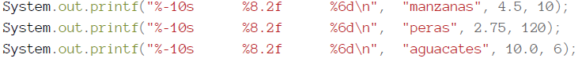
      6. 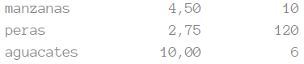
2. **Caracteres de escape**
   1. \n salto de línea \t tabulador \” \’ \\
3. **Caracteres especiales**
   1. <http://www.unicode.org/charts/> **Unicode** : de \u0000 a \uFFFF
4. **Coloreado de texto por la salida de la consola**
   1. System.*out*.println("**\033**[31mEste texto es Rojo");
   2. System.*out*.println("**\033**[32mEste texto es Verde");
   3. //public static final String BLACK="\033[30m"; RED="\033[31m"; GREEN="\033[32m"; YELLOW ="\033[33m"; BLUE = "\033[34m"; PURPLE = "\033[35m"; CYAN = "\033[36m"; WHITE = "\033[37m";
   4. El color antes de la cadena System.*out*.println(**color** + txt);
   5. System.*out*.println(**RED** +”Hola soy rojo”);
   6. System.*out*.println(**RED** +”Hola soy rojo” + **BLUE** + ‘Soy azul’);
5. **Nombres de variables**
   1. Las variables se crean con estilo lowerCamelCase.
   2. Puede contener números y guiones bajos , pero no empezar por número.
   3. <https://google.github.io/styleguide/javaguide.html>
6. **Tipos de datos:**
   1. boolean(1) true or false
   2. byte(1) Stores whole numbers from -128 to 127
   3. short(2) Stores whole numbers from -32,768 to 32,767
   4. int(4) Stores whole numbers from -2,147,483,648 to 2,147,483,647
   5. long(8) -9,223,372,036,854,775,808 to 9,223,372,036,854,775,808
   6. float(4) Fractional numbers from 3.4e−038 to 3.4e+038
   7. double(8) 1.7e−308 to 1.7e+038
   8. char(2) Stores a single character/letter or ASCII values
   9. String
   10. Arrays
   11. Classes
7. Ejemplos
   1. int myNum = 5;
   2. char myLetter = 'D';
   3. char myVar1 = 65;
   4. boolean myBool = true;
   5. String myText = "Hello";
   6. int x = 5, y = 6, z = 50;
   7. int x, y, z;
   8. x = y = z = 50;
   9. long myNum = 15000000000L; //OJO L al final
   10. float myNum = 5.75f; //OJO f al final
   11. double myNum = 19.99d; //OJO d al final
   12. **final** int myNum = 15; (final=Valor **constante** no modificable)
8. **Java Type Casting**

* **Widening Casting** (automatically) - converting a smaller type to a larger type size  
  byte -> short -> char -> int -> long -> float -> double
* **Narrowing Casting** (manually) - converting a larger type to a smaller size type  
  double -> float -> long -> int -> char -> short -> byte

**Widening casting** is done automatically

public class Main {

public static void main(String[] args) {

int myInt = 9;

double myDouble = myInt; // **Automatic casting: int to double**

System.out.println(myInt); // Outputs 9

System.out.println(myDouble); // Outputs 9.0

}

}

**Narrowing casting** must be done manually

public class Main {

public static void main(String[] args) {

double myDouble = 9.78d;

int myInt = **(int)** myDouble; // **Manual casting: double to int**

System.out.println(myDouble); // Outputs 9.78

System.out.println(myInt); // Outputs 9

}

**Otro Ejemplo:**

public class ConversionDeTipos {

public static void main(String[] args) {

int x = 2;

int y = 9;

double division;

division = **(double)**y / **(double)**x;

//division = y / x; // Comenta esta línea y

// observa la diferencia.

System.out.println("El resultado de la división es " + division);

}

}

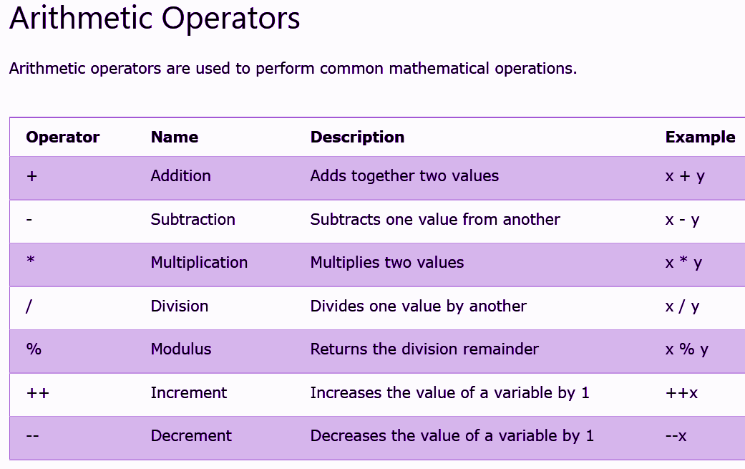

1. **OPERADORES**

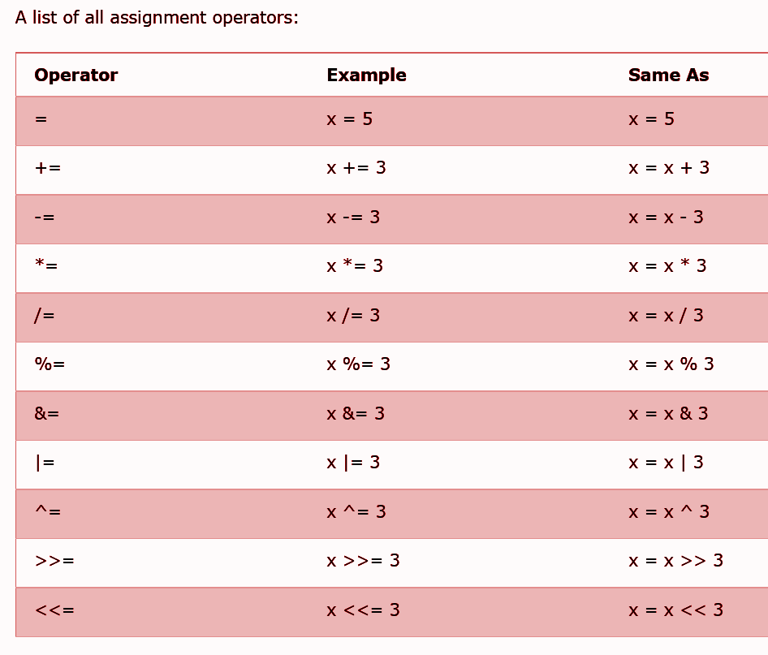

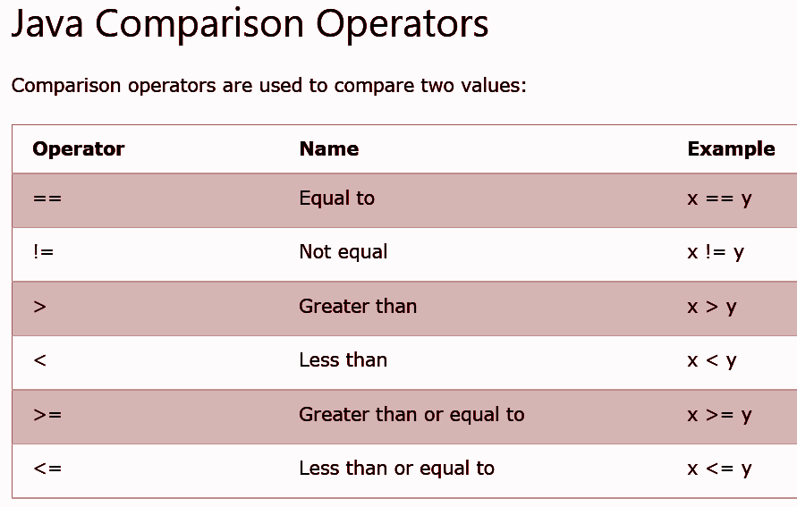

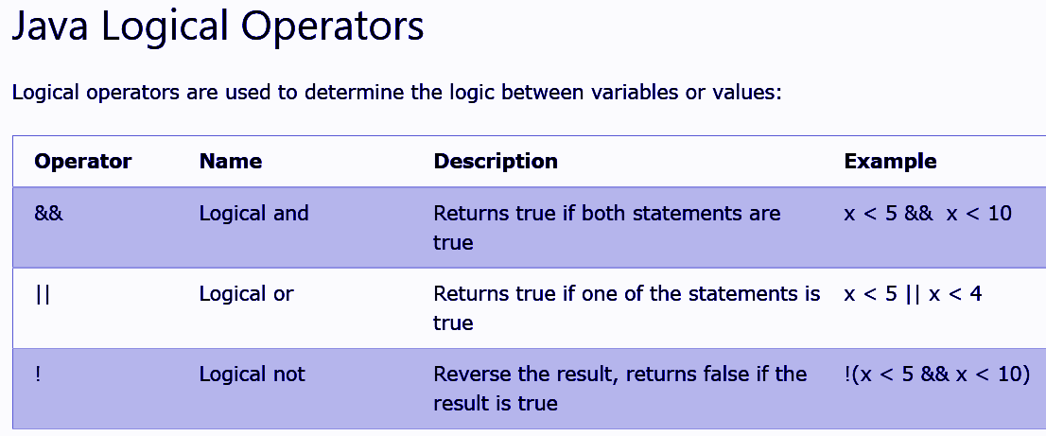

1. **Strings** [**Java String Reference (w3schools.com)**](https://www.w3schools.com/java/java_ref_string.asp)

String txt = "ABCDEFGHIJKLMNOPQRSTUVWXYZ";

System.out.println("The length of the txt string is: " **+** txt.**length**());

String txt = "Hello World";

System.out.println(txt.**toUpperCase**()); // Outputs "HELLO WORLD"

System.out.println(txt.**toLowerCase**()); // Outputs "hello world"

String txt = "Please locate where 'locate' occurs!";

System.out.println(txt.**indexOf**("locate")); // Outputs 7

|  |  |  |
| --- | --- | --- |
| [charAt()](https://www.w3schools.com/java/ref_string_charat.asp) | Returns the character at the specified index (position) | char |
| [codePointAt()](https://www.w3schools.com/java/ref_string_codepointat.asp) | Returns the Unicode of the character at the specified index | int |
| [codePointBefore()](https://www.w3schools.com/java/ref_string_codepointbefore.asp) | Returns the Unicode of the character before the specified index | int |
| [codePointCount()](https://www.w3schools.com/java/ref_string_codepointcount.asp) | Returns the number of Unicode values found in a string. | int |
| [compareTo()](https://www.w3schools.com/java/ref_string_compareto.asp) | Compares two strings lexicographically | int |
| [compareToIgnoreCase()](https://www.w3schools.com/java/ref_string_comparetoignorecase.asp) | Compares two strings lexicographically, ignoring case differences | int |
| [concat()](https://www.w3schools.com/java/ref_string_concat.asp) | Appends a string to the end of another string | String |
| [contains()](https://www.w3schools.com/java/ref_string_contains.asp) | Checks whether a string contains a sequence of characters | boolean |
| [contentEquals()](https://www.w3schools.com/java/ref_string_contentequals.asp) | Checks whether a string contains the exact same sequence of characters of the specified CharSequence or StringBuffer | boolean |
| [copyValueOf()](https://www.w3schools.com/java/ref_string_copyvalueof.asp) | Returns a String that represents the characters of the character array | String |
| [endsWith()](https://www.w3schools.com/java/ref_string_endswith.asp) | Checks whether a string ends with the specified character(s) | boolean |
| [equals()](https://www.w3schools.com/java/ref_string_equals.asp) | Compares two strings. Returns true if the strings are equal, and false if not | boolean |
| [equalsIgnoreCase()](https://www.w3schools.com/java/ref_string_equalsignorecase.asp) | Compares two strings, ignoring case considerations | boolean |
| format() | Returns a formatted string using the specified locale, format string, and arguments | String |
| getBytes() | Encodes this String into a sequence of bytes using the named charset, storing the result into a new byte array | byte[] |
| getChars() | Copies characters from a string to an array of chars | void |
| [hashCode()](https://www.w3schools.com/java/ref_string_hashcode.asp) | Returns the hash code of a string | int |
| [indexOf()](https://www.w3schools.com/java/ref_string_indexof.asp) | Returns the position of the first found occurrence of specified characters in a string | int |
| intern() | Returns the canonical representation for the string object | String |
| [isEmpty()](https://www.w3schools.com/java/ref_string_isempty.asp) | Checks whether a string is empty or not | boolean |
| [lastIndexOf()](https://www.w3schools.com/java/ref_string_lastindexof.asp) | Returns the position of the last found occurrence of specified characters in a string | int |
| [length()](https://www.w3schools.com/java/ref_string_length.asp) | Returns the length of a specified string | int |
| matches() | Searches a string for a match against a regular expression, and returns the matches | boolean |
| offsetByCodePoints() | Returns the index within this String that is offset from the given index by codePointOffset code points | int |
| regionMatches() | Tests if two string regions are equal | boolean |
| [replace()](https://www.w3schools.com/java/ref_string_replace.asp) | Searches a string for a specified value, and returns a new string where the specified values are replaced | String |
| replaceFirst() | Replaces the first occurrence of a substring that matches the given regular expression with the given replacement | String |
| replaceAll() | Replaces each substring of this string that matches the given regular expression with the given replacement | String |
| split() | Splits a string into an array of substrings | String[] |
| [startsWith()](https://www.w3schools.com/java/ref_string_startswith.asp) | Checks whether a string starts with specified characters | boolean |
| subSequence() | Returns a new character sequence that is a subsequence of this sequence | CharSequence |
| substring() | Returns a new string which is the substring of a specified string | String |
| toCharArray() | Converts this string to a new character array | char[] |
| [toLowerCase()](https://www.w3schools.com/java/ref_string_tolowercase.asp) | Converts a string to lower case letters | String |
| toString() | Returns the value of a String object | String |
| [toUpperCase()](https://www.w3schools.com/java/ref_string_touppercase.asp) | Converts a string to upper case letters | String |
| [trim()](https://www.w3schools.com/java/ref_string_trim.asp) | Removes whitespace from both ends of a string | String |
| valueOf() | Returns the string representation of the specified value | String |

1. **Math**

System.out.println(**Math**.abs(4.7));

| [abs(x)](https://www.w3schools.com/java/ref_math_abs.asp) | Returns the absolute value of x | double|float|int|long |
| --- | --- | --- |
| [acos(x)](https://www.w3schools.com/java/ref_math_acos.asp) | Returns the arccosine of x, in radians | double |
| [asin(x)](https://www.w3schools.com/java/ref_math_asin.asp) | Returns the arcsine of x, in radians | double |
| atan(x) | Returns the arctangent of x as a numeric value between -PI/2 and PI/2 radians | double |
| atan2(y,x) | Returns the angle theta from the conversion of rectangular coordinates (x, y) to polar coordinates (r, theta). | double |
| cbrt(x) | Returns the cube root of x | double |
| ceil(x) | Returns the value of x rounded up to its nearest integer | double |
| copySign(x, y) | Returns the first floating point x with the sign of the second floating point y | double |
| cos(x) | Returns the cosine of x (x is in radians) | double |
| cosh(x) | Returns the hyperbolic cosine of a double value | double |
| exp(x) | Returns the value of Ex | double |
| expm1(x) | Returns ex -1 | double |
| floor(x) | Returns the value of x rounded down to its nearest integer | double |
| getExponent(x) | Returns the unbiased exponent used in x | int |
| hypot(x, y) | Returns sqrt(x2 +y2) without intermediate overflow or underflow | double |
| IEEEremainder(x, y) | Computes the remainder operation on x and y as prescribed by the IEEE 754 standard | double |
| log(x) | Returns the natural logarithm (base E) of x | double |
| log10(x) | Returns the base 10 logarithm of x | double |
| log1p(x) | Returns the natural logarithm (base E) of the sum of x and 1 | double |
| max(x, y) | Returns the number with the highest value | double|float|int|long |
| min(x, y) | Returns the number with the lowest value | double|float|int|long |
| nextAfter(x, y) | Returns the floating point number adjacent to x in the direction of y | double|float |
| nextUp(x) | Returns the floating point value adjacent to x in the direction of positive infinity | double|float |
| pow(x, y) | Returns the value of x to the power of y | double |
| random() | Returns a random number between 0 and 1 | double |
| round(x) | Returns the value of x rounded to its nearest integer | int |
| rint(x) | Returns the double value that is closest to x and equal to a mathematical integer | double |
| signum(x) | Returns the sign of x | double |
| sin(x) | Returns the sine of x (x is in radians) | double |
| sinh(x) | Returns the hyperbolic sine of a double value | double |
| sqrt(x) | Returns the square root of x | double |
| tan(x) | Returns the tangent of an angle | double |
| tanh(x) | Returns the hyperbolic tangent of a double value | double |
| toDegrees(x) | Converts an angle measured in radians to an approx. equivalent angle measured in degrees | double |
| toRadians(x) | Converts an angle measured in degrees to an approx. angle measured in radians | double |
| ulp(x) | Returns the size of the unit of least precision (ulp) of x | double|float |

1. **If , Switch , While , For**

**if** (*condition1*) {

*// block of code to be executed if condition1 is true*

} else if (*condition2*) {

*// block of code to be executed if the condition1 is false and condition2 is true*

} else {

*// block of code to be executed if the condition1 is false and condition2 is false*

}

**operador ?**

*variable = (condition) ? expressionTrue : expressionFalse;*

String result = (time < 18) ? "Good day." : "Good evening.";

**switch**(*expression*) {

case x:

*// code block*

break;

case y:

*// code block*

break;

default:

*// code block*

}

**while** (*condition*) {

*// code block to be executed*

}

**do** {

*// code block to be executed*

}

**while** (*condition*);

**for** (*statement 1*; *statement 2*; *statement 3*) {

*// code block to be executed*

}

String[] cars = {"Volvo", "BMW", "Ford", "Mazda"};

for (String **i : cars**) { // **FOR-EACH in Array**

System.out.println(i);

}

1. **Arrays**

String[] cars = {"Volvo", "BMW", "Ford", "Mazda"};

int[] myNum = {10, 20, 30, 40};

String[] cars = {"Volvo", "BMW", "Ford", "Mazda"};

cars[0] = "Opel";

System.out.println(cars[0]);

System.out.println(cars.length);

int[][] myNumbers = { {1, 2, 3, 4}, {5, 6, 7} };

int x = myNumbers[1][2];

int[][] myNumbers = { {1, 2, 3, 4}, {5, 6, 7} };

for (int i = 0; i < myNumbers.length; ++i) {

for(int j = 0; j < myNumbers[i].length; ++j) {

System.out.println(myNumbers[i][j]);

}

}

1. **Java Methods**

public class MyMain {

static void myMethod(String fname, int age) {

System.out.println(fname + " is " + age);

}

public static void main(String[] args) {

myMethod("Liam", 5);

myMethod("Jenny", 8);

myMethod("Anja", 31);

}

}

* myMethod() is the name of the method
* static means that the method belongs to the MyMain class and not an object of the MyMain class.
* void means that this method does not have a return value.

**Return**

public class MyMain {

static **int** myMethod(int x, int y) {

**return** x + y;

}

public static void main(String[] args) {

int z = myMethod(5, 3);

System.out.println(z);

}

}

// Outputs 8 (5 + 3)

**Overloading (Polimorfismo overload)**

With method overloading, multiple methods can have the same name with **different parameters ( different data types and /or number of parameters)**:

public class MyMain {

static **int plusMethod**(int x, int y) {

return x + y;

}

static **double plusMethod**(double x, double y) {

return x + y;

}

public static void main(String[] args) {

int myNum1 = **plusMethod(8, 5);**

double myNum2 = **plusMethod(4.3, 6.26);**

System.out.println("int: " + myNum1);

System.out.println("double: " + myNum2);

}

}

**Scope**

public class MyMain {

public static void main(String[] args) {

// Code here CANNOT use x

{ // This is a block

// Code here CANNOT use x

**int x = 100;**

// Code here CAN use x

System.out.println(x);

} // The block ends here

// Code here CANNOT use x

}

}

**Java Clases**

public class MyMain {

String fname = "John"; // atributos de la clase

String lname = "Doe";

int age = 24;

public static void main(String[] args) {

Main myObj = new MyMain();

System.out.println("Name: " + myObj.fname + " " + myObj.lname);

System.out.println("Age: " + myObj.age);

}

}

**static y public**

An example to demonstrate the differences between static and public methods:

public class Main {

// Static method

**static** void myStaticMethod() {

System.out.println("Static methods can be called without creating objects");

}

// Public method

**public** void myPublicMethod() {

System.out.println("Public methods must be called by creating objects");

}

// Main method

public static void main(String[] args) {

myStaticMethod(); // Call the static method

// myPublicMethod(); This would compile an error

Main myObj = new Main(); // Create an object of Main

myObj.myPublicMethod(); // Call the public method on the object

}

}

## Using Multiple Classes

Like we specified in the [Classes chapter](https://www.w3schools.com/java/java_classes.asp), it is a good practice to create an object of a class and access it in another class.

Remember that the name of the java file should match the class name. In this example, we have created two files in the same directory:

* Main.java
* Second.java

#### Main.java

public class Main {

public void fullThrottle() {

System.out.println("The car is going as fast as it can!");

}

public void speed(int maxSpeed) {

System.out.println("Max speed is: " + maxSpeed);

}

}

#### Second.java

class Second {

public static void main(String[] args) {

Main myCar = new Main(); // Create a myCar object

myCar.fullThrottle(); // Call the fullThrottle() method

myCar.speed(200); // Call the speed() method

}

}

When both files have been compiled:

C:\Users*Your Name*>javac Main.java

C:\Users*Your Name*>javac Second.java

Run the Second.java file:

C:\Users*Your Name*>java Second

And the output will be:

The car is going as fast as it can!

Max speed is: 200

**Constructor method**

public class Main {

int modelYear;

String modelName;

// no es obligatorio tener un constructor

public Main(int year, String name) { **//constructor parametrizado**

modelYear = year;

modelName = name;

}

public static void main(String[] args) {

Main myCar = new Main(1969, "Mustang");

System.out.println(myCar.modelYear + " " + myCar.modelName);

}

}

# Java Modifiers

# By now, you are quite familiar with the public keyword that appears in almost all of our examples:

**public** class Main

The **public** keyword is an access modifier, meaning that it is used to set the access level for classes, attributes, methods and constructors.

We divide modifiers into two groups:

* **Access Modifiers** - controls the access level
* **Non-Access Modifiers** - do not control access level, but provides other functionality

## Access Modifiers

**For classes**, you can use either public or *default*:

| **Modifier** | **Description** | **Try it** |
| --- | --- | --- |
| public | The class is accessible by any other class | [Try it »](https://www.w3schools.com/java/tryjava.asp?filename=demo_mod_public) |
| *default* | The class is only accessible by classes in the same package. This is used when you don't specify a modifier. You will learn more about packages in the [Packages chapter](https://www.w3schools.com/java/java_packages.asp) | [Try it »](https://www.w3schools.com/java/tryjava.asp?filename=demo_mod_default) |

**For attributes, methods and constructors**, you can use the one of the following:

| **Modifier** | **Description** | **Try it** |
| --- | --- | --- |
| public | The code is accessible for all classes | [Try it »](https://www.w3schools.com/java/tryjava_multi.asp?filename=demo_mod_public2&multi=demo_mod_public2_multi) |
| private | The code is only accessible within the declared class | [Try it »](https://www.w3schools.com/java/tryjava.asp?filename=demo_access_mod) |
| *default* | The code is only accessible in the same package. This is used when you don't specify a modifier. You will learn more about packages in the [Packages chapter](https://www.w3schools.com/java/java_packages.asp) | [Try it »](https://www.w3schools.com/java/tryjava.asp?filename=demo_mod_default2) |
| protected | The code is accessible in the same package and subclasses. You will learn more about subclasses and superclasses in the [Inheritance chapter](https://www.w3schools.com/java/java_inheritance.asp) | [Try it »](https://www.w3schools.com/java/tryjava.asp?filename=demo_mod_protected) |

## 

## Non-Access Modifiers

**For classes**, you can use either final or abstract:

| **Modifier** | **Description** | **Try it** |
| --- | --- | --- |
| final | The class cannot be inherited by other classes (You will learn more about inheritance in the [Inheritance chapter](https://www.w3schools.com/java/java_inheritance.asp)) | [Try it »](https://www.w3schools.com/java/tryjava.asp?filename=demo_inherit_final) |
| abstract | The class cannot be used to create objects (To access an abstract class, it must be inherited from another class. You will learn more about inheritance and abstraction in the [Inheritance](https://www.w3schools.com/java/java_inheritance.asp) and [Abstraction](https://www.w3schools.com/java/java_abstract.asp) chapters) | [Try it »](https://www.w3schools.com/java/tryjava_multi.asp?filename=demo_mod_abstract&multi=demo_mod_abstract_multi) |

**For attributes and methods**, you can use the one of the following:

| **Modifier** | **Description** |
| --- | --- |
| final | **Attributes and methods** cannot be overridden/modified |
| static | **Attributes and methods** belongs to the class, rather than an object |
| abstract | Can only be used in an abstract class, and can only be used on methods. The method does not have a body, for example abstract void run();. The body is provided by the subclass (inherited from). You will learn more about inheritance and abstraction in the [Inheritance](https://www.w3schools.com/java/java_inheritance.asp) and [Abstraction](https://www.w3schools.com/java/java_abstract.asp) chapters |
| transient | **Attributes and methods** are skipped when serializing the object containing them |
| synchronized | Methods can only be accessed by one thread at a time |
| volatile | The value of an attribute is not cached thread-locally, and is always read from the "main memory" |

## Naming Conventions of the Different Identifiers

The following table shows the popular conventions used for the different identifiers.

| **Identifiers Type** | **Naming Rules** | **Examples** |
| --- | --- | --- |
| Class | It should start with the uppercase letter.  It should be a noun such as Color, Button, System, Thread, etc.  Use appropriate words, instead of acronyms. | public class **Employee**  {  //code snippet  } |
| Interface | It should start with the uppercase letter.  It should be an adjective such as Runnable, Remote, ActionListener.  Use appropriate words, instead of acronyms. | interface **Printable**  {  //code snippet  } |
| Method | It should start with lowercase letter.  It should be a verb such as main(), print(), println().  If the name contains multiple words, start it with a lowercase letter followed by an uppercase letter such as actionPerformed(). | class Employee  {  // method  void **draw()**  {  //code snippet  }  } |
| Variable | It should start with a lowercase letter such as id, name.  It should not start with the special characters like & (ampersand), $ (dollar), _ (underscore).  If the name contains multiple words, start it with the lowercase letter followed by an uppercase letter such as firstName, lastName.  Avoid using one-character variables such as x, y, z. | class Employee  {  // variable  int **id**;  //code snippet  } |
| Package | It should be a lowercase letter such as java, lang.  If the name contains multiple words, it should be separated by dots (.) such as java.util, java.lang. | //package  package **com.javatpoint;**  class Employee  {  //code snippet  } |
| Constant | It should be in uppercase letters such as RED, YELLOW.  If the name contains multiple words, it should be separated by an underscore(_) such as MAX_PRIORITY.  It may contain digits but not as the first letter. | class Employee  {  //constant  static final int **MIN_AGE** = 18;  //code snippet  } |

## CamelCase in Java naming conventions

Java follows camel-case syntax for naming the class, interface, method, and variable.

If the name is combined with two words, the second word will start with uppercase letter always such as actionPerformed(), firstName, ActionEvent, ActionListener, etc.

# Java Encapsulation

# The meaning of Encapsulation, is to make sure that "sensitive" data is hidden from users. To achieve this, you must:

* declare class variables/attributes as **private**
* provide public **get and set** methods to access and update the value of a private variable

## Get and Set

You learned from the previous chapter that private variables can only be accessed within the same class (an outside class has no access to it). However, it is possible to access them if we provide public get and set methods. The get method returns the variable value, and the set method sets the value. Syntax for both is that they start with either get or set, followed by the name of the variable, with the first letter in upper case:

public class Person {

**private** String name; **// private = restricted access**

// Getter

public String **getName**() {

return name;

}

// Setter

public void **setName**(String newName) {

this.name = newName;

}

}

# 

# Java Packages & API

A package in Java is used to group related classes. Think of it as a folder in a file directory. We use packages to avoid name conflicts, and to write a better maintainable code. Packages are divided into two categories:

* Built-in Packages (packages from the Java API)
* User-defined Packages (create your own packages)

## Built-in Packages

The Java API is a library of prewritten classes, that are free to use, included in the Java Development Environment.

The library contains components for managing input, database programming, and much much more. The complete list can be found at Oracles website: [**https://docs.oracle.com/javase/8/docs/api/**](https://docs.oracle.com/javase/8/docs/api/)**.**

The library is divided into packages and classes. Meaning you can either import a single class (along with its methods and attributes), or a whole package that contain all the classes that belong to the specified package.

To use a class or a package from the library, you need to use the import keyword:

import *package*.*name*.*Class*; // Import a single class

import *package*.*name*.*; // Import the whole package

## Import a Class

If you find a class you want to use, for example, the Scanner class, which is used to get user input, write the following code:

import java.util.Scanner;

In the example above, java.util is a package, while Scanner is a class of the java.util package. To use the Scanner class, create an object of the class and use any of the available methods found in the Scanner class documentation. In our example, we will use the nextLine() method, which is used to read a complete line:

Using the Scanner class to get user input:

import java.util.Scanner;

class MyClass {

public static void main(String[] args) {

Scanner myObj = new Scanner(System.in);

System.out.println("Enter username");

String userName = myObj.nextLine();

System.out.println("Username is: " + userName);

}

}

Import a Package

There are many packages to choose from. In the previous example, we used the Scanner class from the java.util package. This package also contains date and time facilities, random-number generator and other utility classes.

To import a whole package, end the sentence with an asterisk sign (*). The following example will import ALL the classes in the java.util package:

import java.util.*;

## User-defined Packages

To create your own package, you need to understand that Java uses a file system directory to store them. Just like folders on your computer:

└── root

└── mypack

└── MyPackageClass.java

To create a package, use the **package** keyword:

### MyPackageClass.java

**package** mypack;

class MyPackageClass {

public static void main(String[] args) {

System.out.println("This is my package!");

}

}

Save the file as MyPackageClass.java, and compile it:

C:\Users*Your Name*>javac MyPackageClass.java

**Then compile the package:**

C:\Users*Your Name*>javac -d . MyPackageClass.java

This forces the compiler to create the "mypack" package. The -d keyword specifies the destination for where to save the class file. You can use any directory name, like c:/user (windows), or, if you want to keep the package within the same directory, you can use the dot sign ".", like in the example above. Note: The package name should be written in lower case to avoid conflict with class names. When we compiled the package in the example above, a new folder was created, called "mypack". To run the MyPackageClass.java file, write the following:

C:\Users*Your Name*>java mypack.MyPackageClass

The output will be:

This is my package!

## Java Inheritance (Subclass and Superclass)

In Java, it is possible to inherit attributes and methods from one class to another. We group the "inheritance concept" into two categories:

* **subclass** (child) - the class that inherits from another class
* **superclass** (parent) - the class being inherited from

To inherit from a class, use the extends keyword.

In the example below, the Car class (subclass) inherits the attributes and methods from the Vehicle class (superclass):

class Vehicle {

**protected** String brand = "Ford"; // Vehicle attribute

public void honk() { // Vehicle method

System.out.println("Tuut, tuut!");

}

}

class Car **extends** Vehicle {

**private** String modelName = "Mustang"; // Car attribute

public static void main(String[] args) {

// Create a myCar object

Car myCar = new Car();

// Call the honk() method (from the Vehicle class) on the myCar object

myCar.honk();

// Display the value of the brand attribute (from the Vehicle class) and the value of the modelName from the Car class

System.out.println(myCar.brand + " " + myCar.modelName);

}

}

Did you notice the protected modifier in Vehicle? We set the brand attribute in Vehicle to a protected [access modifier](https://www.w3schools.com/java/java_modifiers.asp). If it was set to private, the Car class would not be able to access it.

## The final Keyword

If you don't want other classes to inherit from a class, use the final keyword:

**final** class Vehicle {

...}

## Java Polymorphism (Overriding)

Polymorphism means "many forms", and it occurs when we have many classes that are related to each other by inheritance. Like we specified in the previous chapter; [Inheritance](https://www.w3schools.com/java/java_inheritance.asp) lets us inherit attributes and methods from another class. Polymorphism uses those methods to perform different tasks. This allows us to perform a single action in different ways. For example, think of a superclass called Animal that has a method called animalSound(). Subclasses of Animals could be Pigs, Cats, Dogs, Birds - And they also have their own implementation of an animal sound (the pig oinks, and the cat meows, etc.):

class Animal {

public void animalSound() {

System.out.println("The animal makes a sound");

}

}

class Pig extends Animal {

public void animalSound() {

System.out.println("The pig says: wee wee");

}

}

class Dog extends Animal {

public void animalSound() {

System.out.println("The dog says: bow wow");

}

}

Remember from the [Inheritance chapter](https://www.w3schools.com/java/java_inheritance.asp) that we use the extends keyword to inherit from a class. Now we can create Pig and Dog objects and call the animalSound() method on both of them:

class Animal {

public void animalSound() {

System.out.println("The animal makes a sound");

}

}

class Pig extends Animal {

public void animalSound() {

System.out.println("The pig says: wee wee");

}

}

class Dog extends Animal {

public void animalSound() {

System.out.println("The dog says: bow wow");

}

}

class Main {

public static void main(String[] args) {

Animal myAnimal = new Animal(); // Create a Animal object

Animal myPig = new Pig(); // Create a Pig object

Animal myDog = new Dog(); // Create a Dog object

myAnimal.animalSound();

myPig.animalSound();

myDog.animalSound();

}

## 1) **super** is used to refer immediate parent class instance variable.

We can use super keyword to access the data member or field of parent class. It is used if parent class and child class have same fields.

1. **class** Animal{
2. String color="white";
3. }
4. **class** Dog **extends** Animal{
5. String color="black";
6. **void** printColor(){
7. System.out.println(color);//prints color of Dog class
8. System.out.println(**super**.color);//prints color of Animal class
9. }
10. }
11. **class** TestSuper1{
12. **public** **static** **void** main(String args[]){
13. Dog d=**new** Dog();
14. d.printColor();
15. }}

black

white

## 2) **super** can be used to invoke parent class method

The super keyword can also be used to invoke parent class method. It should be used if subclass contains the same method as parent class. In other words, it is used if method is overridden.

1. **class** Animal{
2. **void** eat(){System.out.println("eating...");}
3. }
4. **class** Dog **extends** Animal{
5. **void** eat(){System.out.println("eating bread...");}
6. **void** bark(){System.out.println("barking...");}
7. **void** work(){
8. **super**.eat();
9. bark();
10. }
11. }
12. **class** TestSuper2{
13. **public** **static** **void** main(String args[]){
14. Dog d=**new** Dog();
15. d.work();
16. }}

eating...

barking...

## 3) **super** is used to invoke parent class constructor.

The super keyword can also be used to invoke the parent class constructor. Let's see a simple example:

1. **class** Animal{
2. Animal(){System.out.println("animal is created");}
3. }
4. **class** Dog **extends** Animal{
5. Dog(){
6. **super**();
7. System.out.println("dog is created");
8. }
9. }
10. **class** TestSuper3{
11. **public** **static** **void** main(String args[]){
12. Dog d=**new** Dog();
13. }}

animal is created

dog is created

**EJEMPLOS JAVA PROGRAMS**

[Java Programs | Java Programming Examples - **JavaTpoint**](https://www.javatpoint.com/java-programs)

**DONDE APRENDER JAVA**

1. Documentación de Oracle [Java Documentation - Get Started (oracle.com)](https://docs.oracle.com/en/java/index.html)
2. Free learning Oracle [Oracle Learning Explorer: Learn Oracle for Free | Oracle University](https://education.oracle.com/learning-explorer#Java).
3. [**https://www.w3schools.com/java/default.asp**](https://www.w3schools.com/java/default.asp)
4. [**https://docs.oracle.com/javase/tutorial/**](https://docs.oracle.com/javase/tutorial/)
5. [**https://www.youtube.com/user/java**](https://www.youtube.com/user/java)
6. <https://www.sololearn.com/>
7. <https://www.tutorialspoint.com/java/index.htm>
8. <https://www.campusmvp.es/recursos/post/Descifrando-Java-lenguaje-plataforma-ediciones-implementaciones.aspx>